

Name: Sarfaraz Farooqi

Seat Number: 23122166

Section: B

Semester: 6th

Subject: Artificial Intelligence

Miss Uzma
Fit Plan Agent

1.Identify the Problem in Context:
The problem is to design an intelligent AI agent called FitPlan that can create a personalised fitness plan for a user based on their fitness goals, current activity level, available time, exercise preferences and progress. The main problem is that people often find it difficult to decide which exercises to perform, how often to exercise and how to organise their workout routine according to their individual needs. A general fitness plan may not be appropriate for every person because users have different goals, routines and levels of physical activity.

2. Problem Formulation:
Textual Representation:
The problem is to design an intelligent AI agent called FitPlan that creates a personalised fitness plan based on the user’s fitness goal, current activity level, workout history, available time and exercise preferences. The agent collects this information through its sensors, analyses the user’s current fitness state, predicts suitable workout requirements and decides the most appropriate exercises, workout schedule, intensity and rest periods. Its goal is to provide a realistic and adaptable fitness routine that helps the user progress towards their fitness goal while avoiding unnecessary workload and maintaining a suitable balance between exercise and recovery. The agent continuously monitors the user’s progress and updates the fitness plan whenever the user’s condition, performance or requirements change.

Graphical Representation
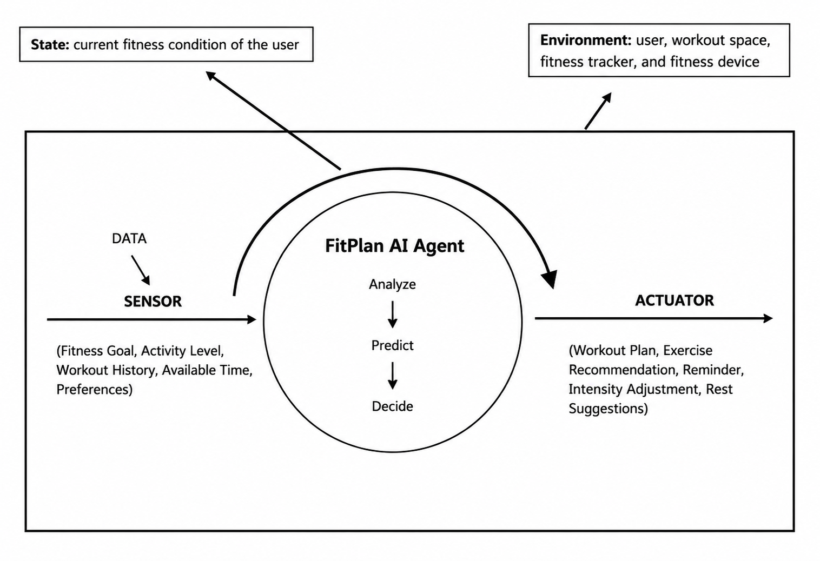

PEAS Framework
P – Performance Measure
FitPlan's performance can be evaluated through:
- Achievement of fitness goals
- Consistency of workouts
- Improvement in activity level
- Appropriate workout intensity
- User satisfaction
- Ability to maintain a realistic routine
E – Environment
- User's daily routine
- Fitness goals
- Workout environment
- Available equipment
- Activity and progress data
- User's schedule
A – Actuators
- Exercise recommendations
- Workout schedule
- Intensity adjustments
- Rest-day suggestions
- Notifications and reminders
- Plan modifications
S – Sensors
- User input
- Fitness tracker
- Step counter
- Workout history
- Activity data
- Progress records

Environment Types
FitPlan can be evaluated using different AI environment types:
Environment Type | FitPlan
Partially Observable | The agent cannot directly observe everything about the user's physical condition or motivation.
Stochastic | The user's performance and progress may vary from day to day.
Sequential | Previous workouts and progress influence future recommendations.
Dynamic | The user's schedule, activity level and progress can change over time.
Continuous | Fitness measurements such as workout duration, steps and exercise intensity can change continuously.
Single Agent | FitPlan primarily works with one user to achieve their fitness goals.

